

**COMPUTER SCIENCE DEPARTMENT**

**FACULTY OF SCIENCE**

**UNIVERSITY OF IBADAN**

DESIGN AND IMPLEMENTATION OF A WEB-BASED DEPARTMENTAL

RESOURCE MANAGEMENT SYSTEM

Submitted in Partial Fulfillment

of the Requirements for the

**BACHELOR OF SCIENCE (B.Sc.) DEGREE IN**

**COMPUTER SCIENCE**

SUBMITTED BY:

**RASAQ Idris Akande | Matric No: E044766**

SUPERVISED BY DR. ADEBOLA OJO

SUBMITTED ON 26/12/2024

**CHAPTER ONE**

**INTRODUCTION**

**1.1 Background to the Study**

In most universities, departments are integral to ensuring the smooth running of both academic and administrative activities. They serve as the backbone of the educational system, where lecturers, students, and administrative staff come together to achieve the academic goals of the institution. However, despite their critical role, many departments still rely on outdated or manual systems to manage the tasks they handle daily. This reliance on traditional methods, though once effective, has become a significant barrier to efficiency, leading to miscommunication, inefficiencies, and often unnecessary stress for everyone involved.

As universities expand, and the student population grows, so does the complexity of the academic environment. Larger departments may face even greater challenges in organizing the increasing number of activities and resources they manage. Tasks such as scheduling, booking equipment, managing lecture notes, and even storing academic records can become overwhelming when handled manually. This issue is further compounded by the fact that many departmental processes are still handled on physical forms, spreadsheets, or even in staff members' personal notes, all of which are prone to human error and inefficiency.

For instance, students often find themselves scrambling to access important academic materials like lecture notes, past project files, or recommended readings because these resources are scattered across various platforms, stored in multiple physical locations, or, in some cases, are entirely unavailable or misplaced. These challenges can lead to a significant waste of time and hinder students’ academic progress to success. Furthermore, without a centralized system, the inability to find necessary materials often causes frustration and impacts students' motivation to stay engaged in their studies.

At the administrative level, managing physical and digital resources, including laboratory equipment, meeting rooms, and lecture halls, can be equally daunting. Double bookings, scheduling conflicts, and lack of proper tracking of resource usage create a ripple effect that affects the entire department. Without an effective system in place to monitor and manage these resources, there is a higher risk of errors that can lead to delays, disruptions, and frustration. The lack of visibility into how resources are utilized often results in underused equipment or overburdened facilities, contributing to a less than optimal academic experience.

Another important aspect is feedback. In the absence of a proper feedback mechanism, students, staff, and faculty may feel disconnected from the department’s decision-making process. Without easy channels to voice concerns, suggest improvements, or commend excellent services, there is no real way to assess or enhance the quality of the department’s operations. Feedback is vital for understanding where processes can be improved, and when feedback is not easily accessible or acted upon, it creates a sense of disengagement from the system.

To tackle these issues and ensure that academic departments can meet the evolving demands of modern higher education, it is essential to implement a solution that brings together all aspects of departmental operations into a streamlined, user-friendly platform. This is where the Departmental Resource Management System (DRMS) comes into play. The goal of this project is to introduce a digital solution that will simplify and automate departmental activities, making them more organized, accessible, and efficient. By centralizing resources, schedules, and feedback, the DRMS aims to create a seamless environment where students, lecturers, and administrators can easily access the information they need to thrive.

Through the implementation of the DRMS, the department can overcome the inefficiencies of traditional resource management, enhance communication, and foster collaboration among all members of the department. This system will provide students with easy access to academic resources, help lecturers and staff manage schedules and resources effectively, and offer a clear, direct path for feedback, ensuring that all voices are heard. As technology continues to reshape the educational landscape, embracing such systems is not just an option, but a necessity for any department that seeks to remain efficient, effective, and relevant in an ever-evolving academic world.

**1.2 Problem Statement**

Universities and their departments serve as critical units for delivering quality education and conducting academic research. However, many departments still rely on outdated, inefficient methods for managing their activities. These traditional systems are often manual, fragmented, and cumbersome, leading to several challenges for students, faculty, and administrative staff. As the educational environment becomes increasingly complex, the need for digital solutions to streamline and improve departmental operations has never been more urgent.

One of the major problems is the lack of a centralized system to manage resources effectively. In many cases, students struggle to access academic materials such as lecture notes, past project reports, and other vital resources. These materials are often scattered across various platforms, shared via emails, or even stored in physical files, making it difficult for students to find and use them when needed. This scattered approach to resource management not only wastes time but also creates a barrier to the smooth flow of academic activities.

On the administrative side, managing resources such as classrooms, laboratories, and meeting spaces often leads to scheduling conflicts and mismanagement. For example, double-booked rooms, unavailability of necessary equipment, or even a lack of transparency in how resources are being utilized, all contribute to the inefficiency of departmental operations. Administrators, without proper digital tools, struggle to keep track of inventory, room bookings, and the overall allocation of resources, often resulting in frustration and delays.

Another significant challenge is the absence of a feedback mechanism that allows students and staff to voice concerns, suggestions, or commendations about departmental processes. Feedback plays a crucial role in improving services, resolving conflicts, and ensuring that both students and faculty members feel heard. Without an easy way to provide feedback or track progress, many departments fail to address critical issues, which directly impacts the quality of the learning experience.

Additionally, the manual and fragmented systems that many departments use often lead to communication breakdowns. For instance, when important announcements or deadlines are shared through emails or notice boards, students may miss them due to lack of synchronization across platforms. Similarly, lecturers and staff members might face delays in communication, which leads to inefficiencies in scheduling, planning, and decision-making.

Given these numerous problems, it is clear that there is a pressing need for a comprehensive digital solution that can address these inefficiencies. The current manual methods of managing departmental activities are no longer sufficient to meet the demands of modern education. A Departmental Resource Management System (DRMS) would centralize all academic and administrative processes, improving resource management, communication, and accessibility of academic materials. Such a system would not only save time and reduce administrative burdens but also enhance the overall student experience by providing easy access to the resources they need to succeed.

In conclusion, the lack of a unified, efficient system for managing departmental resources, scheduling, and communication is a significant issue that hinders the effectiveness of many university departments. This project seeks to solve these problems by designing and implementing a Departmental Resource Management System that will bring greater organization, efficiency, and collaboration to university departments, ultimately benefiting all stakeholders—students, faculty, and administrators alike.

**1.3 Aims and Objectives of the Study**

The Aims of this study is to design and implement a **Departmental Resource Management System (DRMS)** that will streamline and automate the academic and administrative processes within university departments. By addressing the inefficiencies of manual and outdated systems, this study seeks to improve the overall functionality and effectiveness of departmental operations. The objectives of this stud are to:

1. **To Design a Comprehensive Resource Management System for University Departments**
2. **To Improve Communication and Collaboration Among Students, Faculty, and Administrators**
3. **To Automate Resource Scheduling and Management**
4. **To Provide Easy Access to Academic Materials and Resources**
5. **To Enhance Resource Allocation and Usage Tracking**
6. **To Facilitate Continuous Feedback and Improvement**

**1.4 Research Questions**

The research questions guide this study's investigation into the development and implementation of the Departmental Resource Management System (DRMS). These questions are designed to explore the key issues related to departmental resource management, communication, and efficiency, while also assessing the potential benefits and challenges of introducing a digital solution within university departments. The research questions are as follows:

**1.4.1 How can a Departmental Resource Management System improve the management of academic and administrative resources within a university department?**

This question focuses on understanding how a digital system can transform the management of essential academic resources such as lecture notes, past projects, and study materials. It also examines how administrative resources, such as rooms, laboratories, and equipment, can be better organized and tracked through a centralized platform. The goal is to evaluate whether the DRMS can improve the accessibility, allocation, and efficiency of both academic and administrative resources.

**1.4.2 To what extent can the DRMS enhance communication and collaboration among students, lecturers, and administrative staff within the department?**

Effective communication is key to the smooth functioning of any department. This question explores whether implementing a DRMS can facilitate better interaction among the stakeholders involved, students, lecturers, and administrative staff. It also examines how the system can streamline communication by centralizing announcements, notifications, feedback, and discussions in one platform, thereby fostering greater collaboration and engagement across the department.

**1.4.3 What impact does the DRMS have on resource scheduling, usage tracking, and availability management within the department?**

The scheduling and management of resources such as classrooms, laboratories, and equipment can often lead to conflicts or inefficiencies. This question investigates how the DRMS can automate resource scheduling, manage usage effectively, and track availability in real time. It will also assess how the system can reduce conflicts such as double bookings and improve overall resource allocation to avoid underuse or overuse of available resources.

**1.4.4 How can a Departmental Resource Management System facilitate easy access to academic materials and improve the learning experience for students?**

Students often face challenges in accessing academic materials that are stored in various places. This question examines how the DRMS can centralize the storage and distribution of academic resources, making them easily accessible to students at any time. Additionally, it looks into how easy access to lecture notes, project reports, and other learning materials can contribute to a more effective learning experience.

**1.4.5 What are the potential challenges in implementing the DRMS, and how can they be mitigated?**

Any new system or technological solution comes with its set of challenges. This question explores the potential difficulties that may arise during the implementation of the DRMS, such as resistance to change from staff and students, technical limitations, or budget constraints. The study aims to identify these challenges and suggest strategies for overcoming them to ensure smooth system adoption and integration into existing departmental workflows.

**1.4.6 How can feedback from students and staff be effectively collected and utilized within the DRMS to improve departmental operations?**

Feedback is an essential component of any improvement process. This question seeks to understand how the DRMS can incorporate feedback mechanisms, allowing students and staff to provide input on departmental operations, resource management, and other processes. It also explores how this feedback can be analyzed and used to make informed decisions, thereby improving the overall quality of the department's academic and administrative activities.

**1.4.7 What is the overall impact of the DRMS on the efficiency of departmental operations and the satisfaction of stakeholders (students, lecturers, and administrators)?**

Finally, this question aims to evaluate the overall effectiveness of the DRMS once it is implemented. It will assess whether the system has led to improved departmental efficiency, better resource utilization, and a more organized academic environment. Additionally, it will look into the satisfaction levels of students, lecturers, and administrative staff to determine if the DRMS has met their needs and expectations.

**1.5 Objectives of the Study**

The objectives of this study are centered around the design, implementation, and evaluation of the Departmental Resource Management System (DRMS). The system aims to streamline the management of academic and administrative resources within a university department, improve communication, and enhance collaboration among stakeholders. The objectives of this study are as follows:

**1.5.1 To design a comprehensive Departmental Resource Management System (DRMS) tailored for university departments.**

This objective focuses on creating a robust system that addresses the unique needs of university departments. The DRMS will provide a platform for managing academic resources, administrative tasks, and communication within the department. The design will ensure that the system is user-friendly, scalable, and adaptable to different departmental structures.

**1.5.2 To enhance the accessibility of academic materials, such as lecture notes, past projects, and research documents, through digital means.**

One of the primary goals of the DRMS is to centralize academic resources in a way that makes them easily accessible to students, lecturers, and administrative staff. This objective will focus on ensuring that academic materials are well-organized and can be accessed by authorized users at any time, promoting better learning and academic engagement.

**1.5.3 To improve the management and scheduling of resources, such as laboratories, meeting rooms, and equipment, to minimize conflicts and inefficiencies.**

Resource scheduling and management are critical aspects of departmental operations. This objective focuses on developing a system that automates the scheduling process and tracks the availability and usage of resources like classrooms, laboratories, and equipment. By reducing conflicts such as double bookings and underuse of resources, the DRMS aims to improve the overall efficiency of the department.

**1.5.4 To facilitate seamless communication and collaboration between students, lecturers, and administrators.**

Communication breakdowns often hinder smooth operations within university departments. This objective aims to improve communication by providing a platform for announcements, notifications, discussions, and feedback. The system will enable stakeholders to easily share information, exchange ideas, and collaborate on academic and administrative tasks, fostering a more cohesive and productive environment.

**1.5.5 To enable effective feedback collection from students and staff for continuous improvement of departmental operations.**

Another important objective is to integrate feedback mechanisms into the DRMS. This will allow students, lecturers, and administrative staff to provide constructive feedback on the system and other departmental activities. The feedback collected will be analyzed to identify areas for improvement, ensuring that the system remains dynamic and responsive to the needs of its users.

**1.5.6 To assess the impact of the DRMS on the efficiency of departmental operations and stakeholder satisfaction.**

Once the DRMS is implemented, it is crucial to evaluate its effectiveness. This objective involves measuring the impact of the system on departmental efficiency, including time savings, resource utilization, and communication improvements. Additionally, the study will assess stakeholder satisfaction, determining whether the system meets the needs of students, lecturers, and administrators.

**1.5.7 To identify potential challenges and propose solutions for the successful implementation and adoption of the DRMS.**

The successful implementation of the DRMS depends on overcoming various challenges, including resistance to change, technical issues, and budget constraints. This objective aims to identify these challenges and provide recommendations for addressing them, ensuring that the system is smoothly integrated into existing departmental workflows.

**1.6 Scope of the Study**

The scope of this study is focused on the design, development, and implementation of the Departmental Resource Management System (DRMS) for a university department. The system is intended to streamline the management of both academic and administrative resources, and enhance communication among students, lecturers, and administrative staff.

Specifically, the study will focus on:

* **Academic Resource Management:** Organizing and centralizing lecture notes, research documents, past projects, and other materials for easy access by students and staff.
* **Administrative Resource Scheduling:** Managing and scheduling departmental resources such as classrooms, meeting rooms, laboratories, and equipment, with an emphasis on avoiding conflicts and ensuring optimal use of available resources.
* **Communication and Collaboration:** Enabling smooth and efficient communication between students, lecturers, and administrators. This includes announcements, discussions, and feedback mechanisms for continuous improvement.
* **Feedback System Integration:** Incorporating a feedback collection system that allows students and staff to provide feedback on departmental activities and resource usage.
* **Evaluation:** Assessing the system’s effectiveness in terms of resource management efficiency, user satisfaction, and overall impact on departmental operations.

**1.7 Significance of the Study**

The implementation of the Departmental Resource Management System (DRMS) is significant in several ways, both from an academic and administrative perspective.

1. **Improvement of Departmental Efficiency:** One of the major outcomes expected from this study is the improvement in the efficiency of departmental operations. By centralizing academic and administrative resources in one accessible platform, the DRMS will eliminate the inefficiencies associated with manual resource management, such as miscommunications and double-bookings. The result will be smoother operations, reduced administrative burden, and better time management.
2. **Enhanced Learning Experience for Students:** The centralization of academic materials such as lecture notes, projects, and research papers will enhance students' learning experiences by providing them with easy access to essential learning resources. Students will benefit from a more organized and efficient academic environment, which is critical for their academic success.
3. **Better Communication and Collaboration:** One of the key benefits of the DRMS is its ability to improve communication within the department. By providing a platform for announcements, feedback, and discussions, the system will promote better engagement between students, lecturers, and administrators. This improved communication will contribute to a more collaborative and responsive academic environment.
4. **Data-Driven Decision Making:** The feedback system integrated into the DRMS will allow for the continuous collection of data on departmental operations, resource usage, and stakeholder satisfaction. This data can be used to make informed decisions, further enhancing the department’s operational effectiveness and responsiveness to the needs of students and staff.
5. **Potential for Broader Implementation:** While the focus of this study is on one department, the findings and recommendations of this research could serve as a model for other departments within the university or even at other institutions. If successful, the DRMS could be scaled and implemented across multiple departments, further improving efficiency and collaboration within the institution.

**1.8 Definition of Terms**

To ensure clarity, the following terms are defined as they pertain to this study:

* **Departmental Resource Management System (DRMS):** A digital system designed to manage academic and administrative resources within a university department. The system allows for the scheduling of resources, sharing of academic materials, and facilitates communication and collaboration among students, lecturers, and administrative staff.
* **Academic Resources:** These include materials such as lecture notes, textbooks, research papers, past projects, and any other educational content required for students' learning.
* **Administrative Resources:** These refer to physical or digital assets used for the administrative activities of the department, including meeting rooms, laboratories, office spaces, and equipment.
* **Feedback Mechanism:** A system within the DRMS that allows students, lecturers, and administrators to provide feedback on departmental operations and resources.
* **Stakeholders:** Refers to students, lecturers, and administrative staff who interact with and benefit from the Departmental Resource Management System.
* **Efficiency:** Refers to the optimal use of resources, time, and effort to achieve desired outcomes with minimal waste or delays.

**1.9 Organization of the Study**

This study is organized into five chapters, each of which contributes to the overall goal of investigating the design, implementation, and impact of the Departmental Resource Management System (DRMS). The structure of the study is as follows:

* **Chapter 1: Introduction:** This chapter introduces the research problem, the objectives of the study, the scope of the study, and its significance. It also provides definitions of key terms and outlines the organization of the study.
* **Chapter 2: Literature Review:** This chapter reviews existing literature on resource management systems in universities, digital systems for academic management, communication systems in educational institutions, and feedback mechanisms. It explores relevant theories, models, and previous studies that inform the design of the DRMS.
* **Chapter 3: Methodology:** This chapter outlines the research design, data collection methods, system development approach, and tools used in the implementation of the DRMS. It also details how the data will be analyzed to evaluate the system’s effectiveness.
* **Chapter 4: System Design and Implementation:** This chapter presents the detailed design of the Departmental Resource Management System. It discusses the technical aspects of the system, the development process, and its implementation within the chosen department.
* **Chapter 5: Results, Discussion, and Conclusion:** This final chapter presents the findings of the study, including the evaluation of the DRMS in terms of efficiency, user satisfaction, and feedback. It also discusses the implications of the results, offers recommendations for future improvements, and concludes the study.

**1.10 Summary**

Chapter 1 has provided an introduction to the Departmental Resource Management System (DRMS) and set the stage for the rest of the study. It has outlined the background of the research, identified the research questions, and stated the objectives and significance of the study. The chapter also defined key terms used in the study and provided an overview of how the research is structured. In the next chapter, the study will review existing literature to gain insights into current trends and best practices in resource management systems within academic institutions.

**CHAPTER TWO**

**2.1 Introduction**

A literature review provides a comprehensive analysis of existing research and publications related to a specific study. It offers insight into prior works, identifies gaps in current knowledge, and sets the foundation for the current study. For this research on a **Departmental Resource Management System (DRMS)**, the literature review will explore relevant theories, systems, and technological advances that contribute to resource management, academic efficiency, and communication within university departments.

University departments often function as hubs of academic activity, requiring effective management of both academic and administrative resources. However, many departments face challenges such as inefficient manual systems, lack of centralized resource management, and poor communication among students, lecturers, and administrators. These problems are not unique to one institution but are common across many educational settings globally (Mtebe & Raisamo, 2014). Addressing these challenges requires an understanding of how existing systems function, their strengths, and their limitations.

Over the years, technology has played a significant role in transforming the way educational institutions manage resources. From Learning Management Systems (LMS) like Moodle and Blackboard to university-wide Enterprise Resource Planning (ERP) systems, the focus has been on improving efficiency and accessibility (Dahlstrom et al., 2014). However, these systems often lack tailored solutions for departmental-level needs, which require a more granular approach to managing resources, scheduling, and feedback.

The focus of this chapter is to review the existing literature on resource management systems in higher education, emphasizing their impact, limitations, and the role of emerging technologies. The chapter also highlights the importance of effective communication and feedback mechanisms in fostering collaboration and improving departmental operations. Finally, it identifies gaps in existing research and systems, justifying the need for a Departmental Resource Management System (DRMS) tailored to specific departmental needs.

By exploring existing systems, theoretical frameworks, and technological advancements, this review will provide the necessary context for understanding the design and implementation of the DRMS proposed in this study. It will also establish how this research contributes to bridging gaps in resource management and communication within university departments.

**2.2 Conceptual Framework**

The conceptual framework serves as a foundational guide to understanding the principles and ideas underlying the design and implementation of the **Departmental Resource Management System (DRMS)**. It integrates key concepts related to resource management, communication, collaboration, and feedback mechanisms, highlighting their relevance in improving the efficiency of departmental operations in higher education.

**2.2.1 Resource Management Systems in Education**

Resource management refers to the strategic allocation and utilization of available resources to achieve organizational objectives efficiently. In academic institutions, resources include lecture materials, laboratory equipment, meeting spaces, and administrative tools. Effective resource management ensures these assets are optimally used, reducing wastage and enhancing accessibility.

In many universities, resource management is fragmented or handled manually. This creates challenges like duplicate bookings, resource shortages, and confusion among students and staff (Dey et al., 2019). The use of resource management systems, particularly at the departmental level, addresses these issues by centralizing information, automating processes, and providing real-time updates on resource availability.

**2.2.2 Communication and Collaboration Tools**

Departments thrive on effective communication among students, lecturers, and administrators. Miscommunication can lead to missed deadlines, poor coordination, and reduced productivity. Collaboration tools such as shared calendars, instant messaging platforms, and online forums help bridge communication gaps by fostering real-time interactions and shared access to essential information (Adegoke & Olatoye, 2020).

For example, Slack and Microsoft Teams are widely used in corporate and educational environments to facilitate teamwork. However, their general-purpose nature may not fully meet the specific requirements of university departments. The DRMS incorporates communication and collaboration tools tailored to academic settings, such as automated notifications for resource bookings, event scheduling, and feedback sharing.

**2.2.3 Feedback Mechanisms**

Feedback plays a crucial role in improving systems and services within a department. Students and staff often face challenges but may lack a structured way to voice their concerns or suggestions. A well-designed feedback mechanism allows stakeholders to provide input, helping administrators identify pain points and areas for improvement (Brookhart, 2017).

The DRMS integrates feedback collection and analysis features, ensuring that user inputs are systematically recorded and acted upon. For instance, feedback on the availability of learning materials or the usability of lab facilities can inform better resource allocation and decision-making.

**2.2.4 Integration of Technology in Resource Management**

The rapid advancement of technology has paved the way for innovative solutions in resource management. Technologies such as cloud computing, artificial intelligence (AI), and mobile applications are now integral to modern systems.

* **Cloud Computing:** Enables centralized access to departmental data, ensuring scalability and reliability.
* **Artificial Intelligence (AI):** Supports intelligent resource allocation, predictive analytics for usage patterns, and automated feedback analysis (Zhou et al., 2019).
* **Mobile Applications:** Enhance accessibility, allowing users to interact with the system from anywhere, promoting inclusivity and convenience.

By integrating these technologies, the DRMS aligns with modern trends and ensures long-term relevance and usability.

**2.2.5 Benefits of Centralized Systems**

Centralized systems offer numerous advantages, including:

* **Improved Efficiency:** Automating repetitive tasks like scheduling reduces the workload on administrators.
* **Enhanced Accessibility:** Students and lecturers can access resources from a single platform, eliminating the need to use multiple tools.
* **Data-Driven Decision-Making:** Real-time data on resource usage supports informed decision-making and resource optimization.

**2.3 Review of Existing Systems**

To understand the relevance and uniqueness of the proposed Departmental Resource Management System (DRMS), it is essential to review existing systems used in academic and administrative resource management. This section explores systems currently in use, their features, limitations, and contributions to improving efficiency in higher education institutions.

**2.3.1 Learning Management Systems (LMS)**

Learning Management Systems (LMS) such as Moodle, Blackboard, and Canvas are widely adopted in universities to facilitate teaching and learning. These platforms allow educators to upload lecture notes, assignments, and other learning materials while enabling students to access them from any location. They also support features like grading, discussion forums, and video lectures.

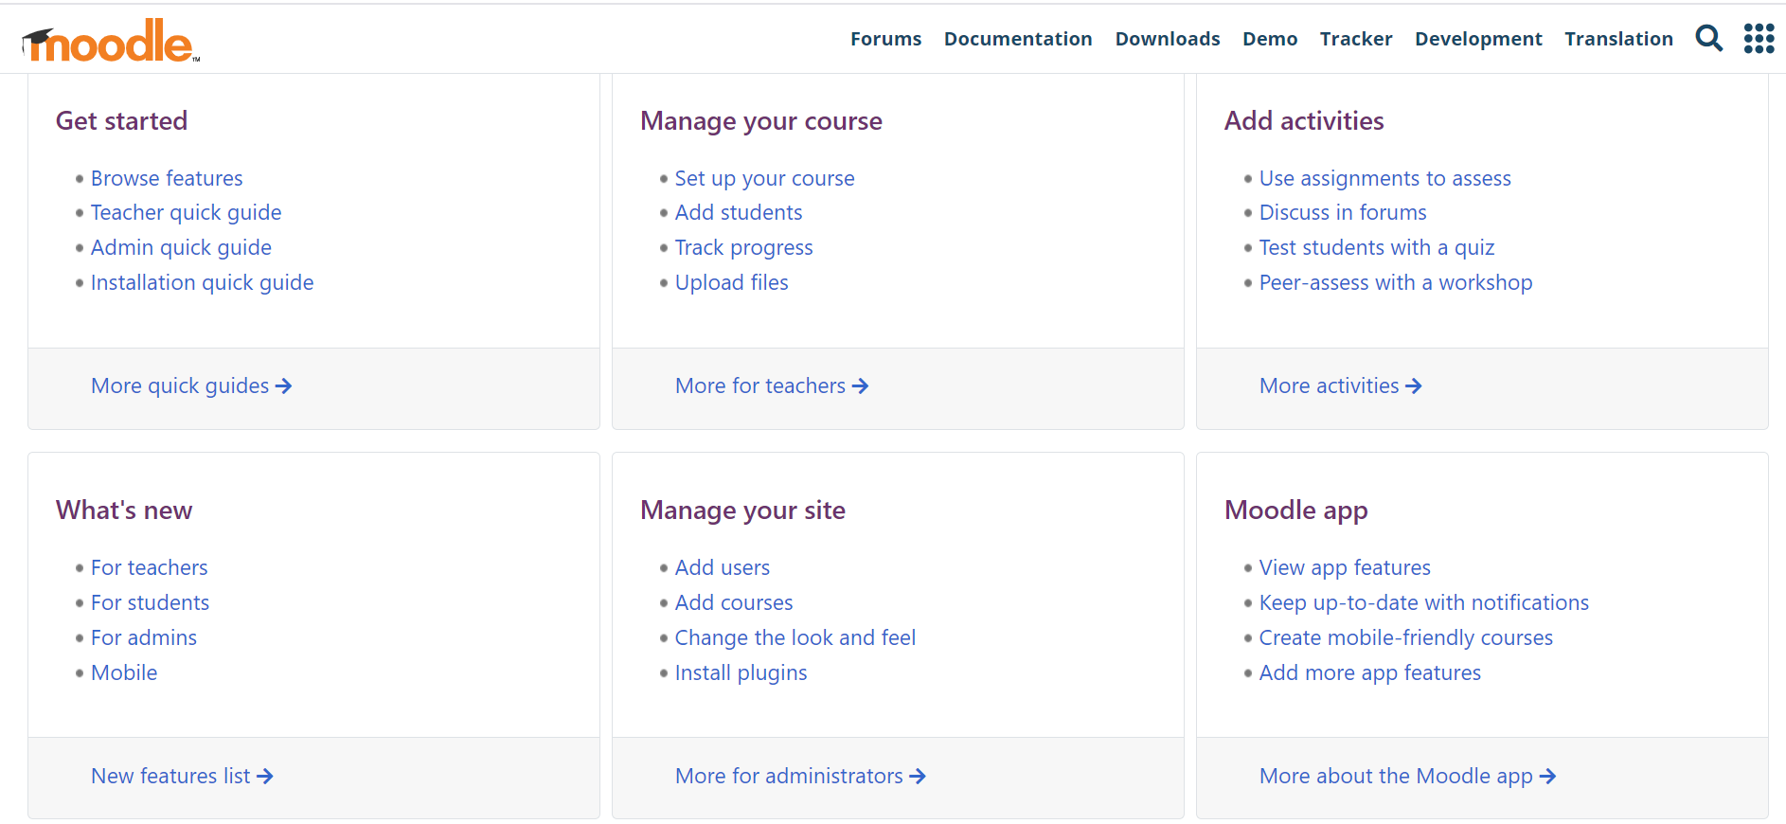

Fig 1.0 – Moodle Documentation Page.

**Limitations:**  
While LMS platforms have transformed classroom interactions, they focus primarily on academic delivery and do not address other departmental needs such as resource booking, feedback collection, or communication beyond coursework. For instance, Moodle, although customizable, lacks modules dedicated to managing physical resources or handling general departmental administration (Al-Sharhan et al., 2015).

**2.3.2 Enterprise Resource Planning (ERP) Systems**

ERP systems, such as Oracle PeopleSoft and SAP ERP, provide comprehensive solutions for managing institutional resources across multiple departments. These systems often integrate functions such as finance, human resources, student information systems, and facility management.

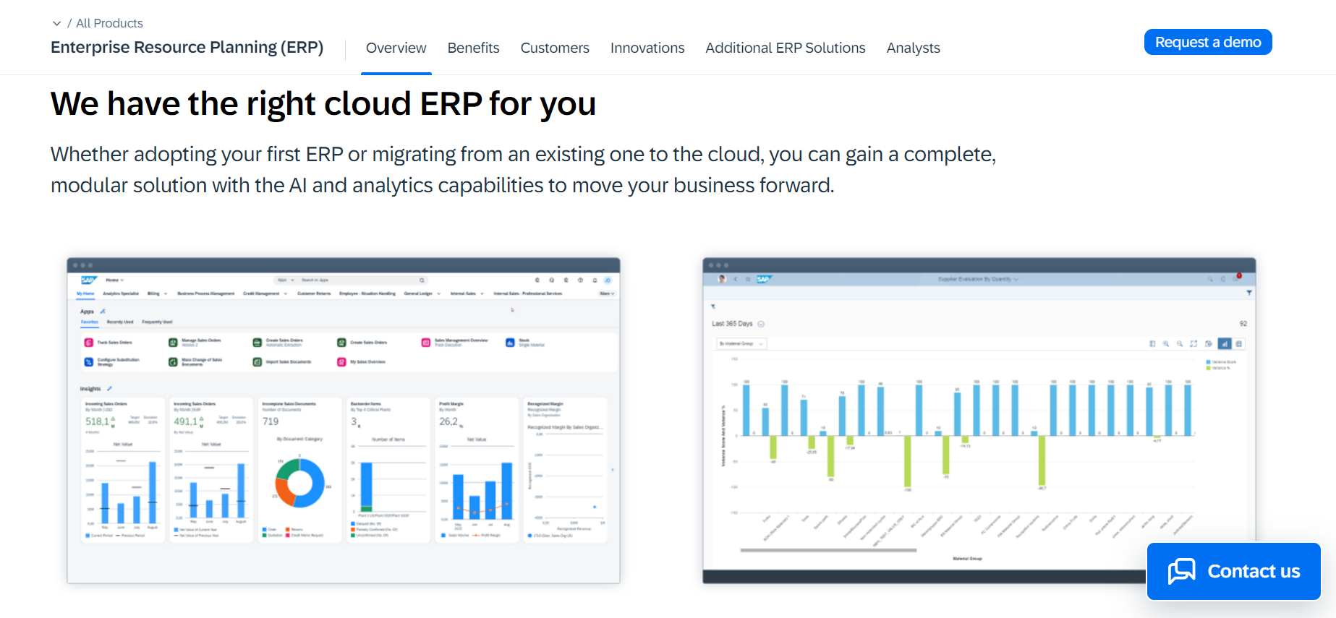

Fig 2.0 – SAP ERP Overview Page.

**Limitations:**  
While ERP systems are robust, they are often designed for university-wide operations rather than department-specific tasks. The complexity and cost of implementing ERP systems make them unsuitable for smaller-scale applications such as a single department. Additionally, ERP systems may not prioritize user-friendly interfaces or address the nuances of specific departmental workflows (Klaus et al., 2000).

**2.3.3 Library Management Systems (LMS)**

Library Management Systems like LibSys manage physical and digital library resources, ensuring users can search, borrow, and return materials efficiently. These systems are often used in academic institutions to handle library operations and provide students with access to research materials.

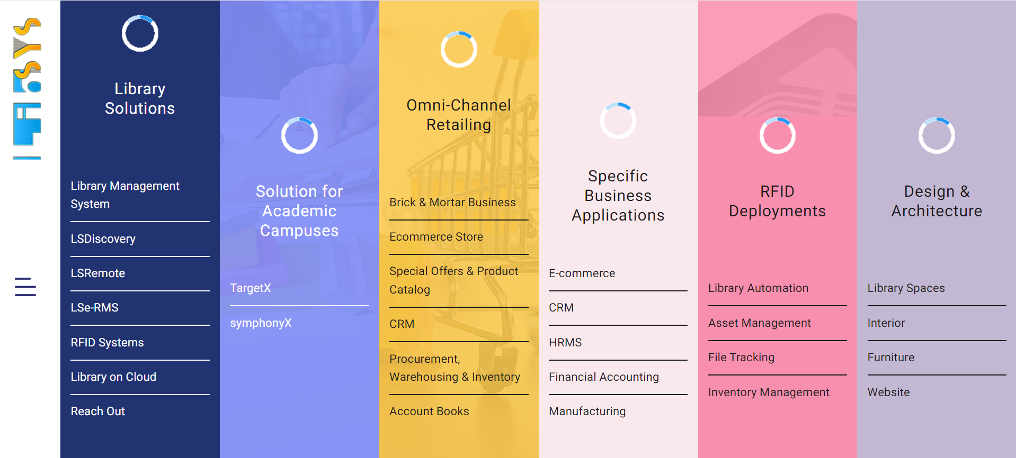

Fig 3.0 – Koha Landing Page.

**Limitations:**  
Library Management Systems are focused on specific library-related tasks and lack features for broader departmental management. They cannot manage resources such as laboratory equipment, meeting rooms, or collaborative tools required for departmental operations.

**2.3.4 Custom-Built Resource Management Tools**

Some universities and departments opt for custom-built software to address their unique needs. These tools often incorporate features such as scheduling, resource tracking, and user management, tailored specifically for the institution. For instance, a department may develop a platform to manage laboratory equipment usage or coordinate meeting room bookings.

**Limitations:**  
Custom-built solutions, while tailored, are often constrained by the budget and expertise of the developers. They may lack scalability, long-term maintenance, and the ability to integrate with other systems. Additionally, many custom solutions fail to provide robust communication and feedback mechanisms, which are critical for improving departmental efficiency (Yang et al., 2016).

**2.3.5 Mobile Applications and Cloud-Based Tools**

Mobile apps and cloud-based tools like Google Workspace and Trello offer features for collaboration, scheduling, and document sharing. These tools are popular due to their accessibility and ease of use, allowing users to manage tasks from anywhere.

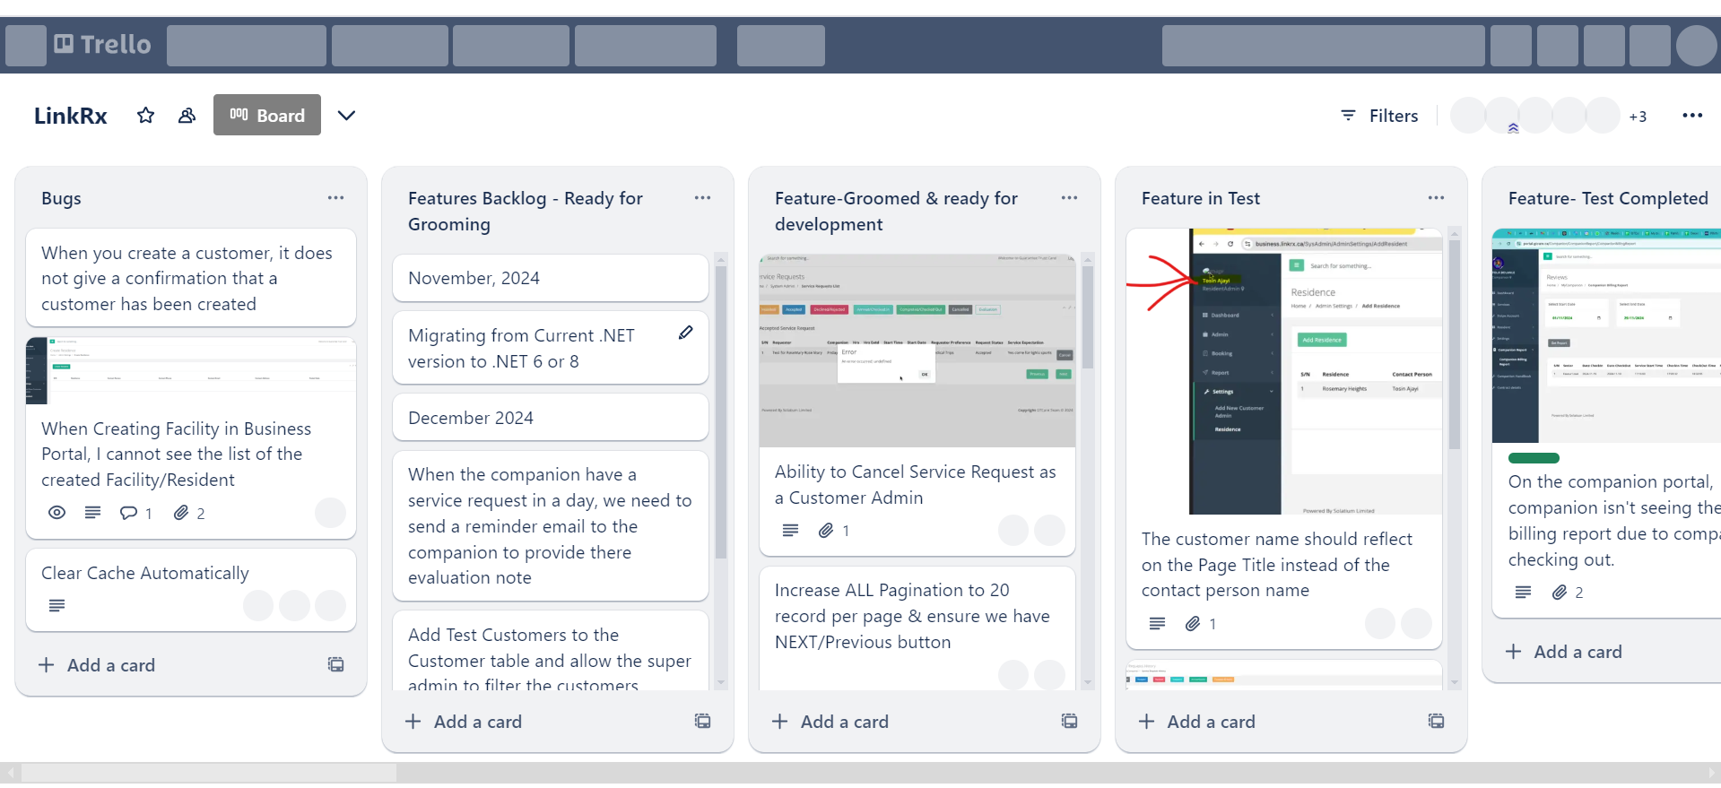

Fig 4.0 – Trello Dashboard.

**Limitations:**  
These tools are general-purpose and not designed for academic settings. They require manual configuration to meet departmental needs and often lack features like integrated feedback collection or resource booking tailored to university departments.

**2.3.6 Identified Gaps in Existing Systems**

Based on the review of existing systems, several gaps can be identified:

1. **Lack of Tailored Solutions:** Most existing systems are either too broad (ERP) or too narrow (Library Management Systems) to effectively address the diverse needs of a university department.
2. **Limited Feedback Mechanisms:** Few systems incorporate robust feedback tools, making it difficult for users to provide input or raise concerns.
3. **Fragmentation:** Many systems focus on a single aspect of management, requiring departments to use multiple platforms, which increases complexity and inefficiency.
4. **Accessibility Issues:** Some systems, particularly ERP platforms, are not easily accessible to all users due to cost, complexity, or lack of mobile compatibility.

**2.3.7 Relevance to the Proposed System**

The proposed DRMS aims to bridge these gaps by providing a unified platform tailored to departmental needs. It will integrate resource booking, communication tools, and feedback mechanisms, addressing the limitations identified in existing systems. By leveraging modern technologies such as cloud computing and mobile accessibility, the DRMS ensures ease of use, scalability, and adaptability to the dynamic requirements of university departments.

**2.4 Technologies Used in Resource Management Systems**

The effectiveness of any resource management system depends significantly on the technologies it employs. Modern systems leverage a wide range of technologies to ensure functionality, scalability, security, and user-friendliness. This section reviews the key technologies commonly used in resource management systems and their relevance to the proposed Departmental Resource Management System (DRMS).

**2.4.1 Database Management Systems (DBMS)**

A robust database is critical for storing and retrieving information in resource management systems. Popular database technologies include:

* **Relational Databases:** Systems like MySQL and PostgreSQL use structured query language (SQL) to manage data in tables. They are reliable for handling structured data such as student records and resource inventories.
* **NoSQL Databases:** MongoDB and Firebase are examples of NoSQL databases that allow for greater flexibility by storing data in key-value pairs, documents, or graphs. These databases are suitable for dynamic, unstructured data, which can be advantageous in managing diverse departmental resources.

**Relevance to DRMS:**  
The proposed system will benefit from a NoSQL database like MongoDB due to its scalability and ability to handle a variety of data formats, including text, images, and feedback records.

**2.4.2 Web Development Technologies**

Modern resource management systems often use web-based platforms to ensure accessibility. Key technologies include:

* **Frontend Frameworks:** React.js, Angular, and Vue.js enable the creation of dynamic and interactive user interfaces.
* **Backend Frameworks:** Node.js, Express.js, and Django provide the server-side logic required for handling user requests, authentication, and data processing.
* **RESTful APIs:** Application Programming Interfaces (APIs) facilitate communication between the frontend and backend, enabling seamless data exchange.

**Relevance to DRMS:**  
React.js will be used for the frontend to deliver an interactive and user-friendly interface, while Node.js and Express.js will power the backend to ensure efficient handling of user actions and database queries.

**2.4.3 Authentication and Authorization Technologies**

Security is crucial in resource management systems, especially in handling sensitive data like student and staff records. Technologies like JWT (JSON Web Tokens), OAuth, and Firebase Authentication are commonly used.

**Relevance to DRMS:**  
The DRMS will employ JWT for secure authentication, ensuring that only authorized users can access departmental resources and functionalities.

**2.4.4 Cloud Computing and Storage**

Cloud platforms such as AWS, Google Cloud, and Microsoft Azure provide scalable and cost-effective solutions for data storage and processing. These platforms enable systems to handle large amounts of data without the need for on-premise infrastructure.

**Relevance to DRMS:**  
To ensure scalability and high availability, the proposed system will utilize a cloud storage solution, allowing users to access resources from anywhere while minimizing downtime.

**2.4.5 Communication and Notification Technologies**

Efficient communication within departments can be facilitated using real-time messaging technologies and notification systems. Popular tools include:

* **WebSocket Protocols:** Enables real-time communication for updates and announcements.
* **Push Notification Services:** Tools like Firebase Cloud Messaging provide instant alerts to users.

**Relevance to DRMS:**  
The DRMS will integrate a notification feature using Firebase Cloud Messaging to alert users about resource availability, schedules, and other departmental updates.

**2.4.6 Mobile and Responsive Technologies**

With the increasing use of smartphones, mobile-friendly systems are crucial for user convenience. Frameworks like React Native, Flutter, and Bootstrap support responsive design and mobile application development.

**Relevance to DRMS:**  
The system will employ responsive design principles using Bootstrap, ensuring compatibility with devices of various screen sizes. Additionally, a mobile application version will be considered for future iterations to enhance accessibility.

**2.4.7 Artificial Intelligence (AI) and Machine Learning (ML)**

Advanced resource management systems incorporate AI and ML to automate repetitive tasks, analyze user behavior, and provide predictive insights.

**Relevance to DRMS:**  
Although the initial implementation may not include AI features, future upgrades can leverage machine learning algorithms to optimize resource allocation and predict user needs based on historical data.

**2.4.8 Security Technologies**

Security is a top priority in resource management systems. Technologies like HTTPS, SSL/TLS, and encryption libraries (e.g., bcrypt) are essential for protecting data during transmission and storage.

**Relevance to DRMS:**  
The system will implement HTTPS for secure communication and encrypt sensitive user information, such as passwords, to prevent unauthorized access.

**2.4.9 Integration Tools**

Resource management systems often integrate with external tools to extend their capabilities. APIs, webhooks, and third-party plugins enable interoperability with other software.

**Relevance to DRMS:**  
The proposed system will include APIs to allow integration with tools such as Google Calendar for scheduling and third-party communication platforms like Slack for enhanced collaboration.

**Conclusion**

The technologies outlined above form the foundation of modern resource management systems, ensuring their effectiveness and adaptability. By integrating these technologies, the proposed DRMS will provide a secure, scalable, and user-friendly platform that meets the unique needs of university departments.

**2.5 Benefits of Departmental Resource Management Systems**

The introduction of departmental resource management systems (DRMS) has transformed how academic institutions handle their resources. These systems come with numerous benefits, which are essential in creating a more efficient, collaborative, and transparent departmental structure.

**2.5.1 Improved Resource Accessibility**

One of the primary advantages of a DRMS is the ability to centralize departmental resources, making them easily accessible to users. Students can conveniently retrieve lecture notes, past projects, and study materials, while lecturers and administrators can upload and manage these resources in real time.

**Example:** A student needing a past project for reference no longer has to rely on outdated filing systems. Instead, they can log into the system, search for the project, and download it instantly.

**2.5.2 Enhanced Communication and Collaboration**

Effective communication is crucial in any academic setup. DRMS facilitates seamless communication between students, lecturers, and administrators through features such as notifications, real-time messaging, and feedback submission.

**Example:** Notifications about upcoming events, resource updates, or urgent announcements can be pushed to users, reducing delays and misunderstandings.

**2.5.3 Efficient Resource Allocation**

Managing departmental resources, such as laboratory equipment, meeting rooms, or computers, becomes more streamlined with a DRMS. Features like booking schedules and availability checks help avoid double-bookings or conflicts.

**Example:** A lecturer needing a projector for a lecture can easily check availability and reserve it without unnecessary paperwork.

**2.5.4 Data-Driven Decision Making**

By analyzing usage patterns, feedback, and other data collected by the system, administrators can make informed decisions. This data helps identify bottlenecks and areas for improvement.

**Example:** If the system shows that students rarely access a particular resource, the department might consider replacing it with more relevant materials.

**2.5.5 Eco-Friendliness and Cost Efficiency**

Replacing manual processes with digital solutions reduces the need for physical paperwork, saving costs and contributing to an eco-friendly environment. Over time, this reduces operational expenses significantly.

**2.5.6 Increased Accountability and Transparency**

By tracking resource usage and feedback, DRMS ensures that all activities are documented, fostering accountability among users. Administrators can monitor who accessed what resources and when, ensuring transparency.

**2.6 Challenges and Limitations of Existing Systems**

Despite their advantages, existing departmental resource management systems often face challenges and limitations that hinder their optimal performance. Understanding these issues is crucial in designing a more effective solution.

**2.6.1 Usability Issues**

Many systems have complex interfaces that make it difficult for users, especially students and non-tech-savvy staff, to navigate them effectively. This results in poor adoption rates.

**Example:** A system with too many steps to access a resource may discourage students from using it, reverting them to manual methods.

**2.6.2 Scalability Concerns**

Some existing systems are not designed to handle growth in user numbers or data volume, leading to performance issues like slow loading times and frequent downtimes.

**2.6.3 Limited Customization**

Generic resource management systems often fail to meet the specific needs of university departments, as they lack customization options tailored to academic environments.

**2.6.4 Lack of Real-Time Features**

Many systems do not support real-time updates, which can lead to inefficiencies, especially in scenarios requiring immediate resource allocation or communication.

**2.6.5 Security Vulnerabilities**

Outdated systems may have insufficient security measures, making them susceptible to data breaches and unauthorized access. This is a significant concern for departments handling sensitive information.

**2.7 Summary**

This chapter explored the concept of resource management systems, their role in enhancing efficiency, and the key technologies powering them. It also highlighted the benefits these systems bring to departments, including improved resource accessibility, enhanced communication, and data-driven decision-making. However, the challenges of existing systems, such as usability issues, scalability concerns, and security vulnerabilities, underscore the need for a more effective solution.

The proposed DRMS aims to address these limitations by leveraging modern technologies and incorporating features tailored to the needs of university departments. This foundation sets the stage for the subsequent chapter, where the design and methodology of the proposed system are detailed.

CHAPTER THREE : METHODOLOGY

**3.1 Research Design**

This study adopts an **exploratory research design**, which is ideal for understanding the existing gaps in departmental resource management and proposing an innovative digital solution. The approach is exploratory because it aims to investigate the challenges within university departments and design a system that addresses these problems using technology. A **qualitative** approach is used to gather insights from academic staff, students, and administrators about their challenges in resource management. The goal is to develop a user-centered system that meets the needs of all stakeholders involved.

**3.2 System Design**

The Departmental Resource Management System (DRMS) is a **web-based application** built on a **client-server architecture**. The system design is structured to allow easy access for all users, including students, lecturers, and administrators, while ensuring that departmental resources like lecture notes, meeting rooms, and equipment are efficiently managed.

The system is composed of three major components:

1. **Frontend (React.js):** The user interface is built using **React.js**, a JavaScript library that allows for a dynamic, responsive, and seamless user experience. React provides the flexibility to create a modular structure, making the system easier to maintain and scale.
2. **Backend (Node.js and Express.js):** The backend of the system is powered by **Node.js**, a JavaScript runtime that provides a fast, scalable environment for handling multiple user requests. **Express.js** is used as the framework for building RESTful APIs to handle requests between the frontend and the database.
3. **Database (MongoDB):** The system uses **MongoDB**, a NoSQL database, to store and manage data related to resources, users, and interactions. MongoDB allows for flexible data storage, which is essential given the variety of resources and information that the system will manage.

**3.3 Development Tools and Technologies**

To build the DRMS, a combination of modern technologies has been selected:

1. **Node.js**: Chosen for its high-performance, non-blocking architecture, making it ideal for real-time applications. Node.js also allows both the frontend and backend to be developed using JavaScript, simplifying the development process.
2. **React.js**: A highly efficient JavaScript library that is designed to build fast and interactive user interfaces. It enables the development of a **single-page application** where users do not have to reload the page to navigate between different sections.
3. **MongoDB**: A NoSQL database that provides high flexibility and scalability. Given that the DRMS will store diverse types of data, including text resources, images, and user feedback, MongoDB is a suitable choice as it can store unstructured data.
4. **Express.js**: A minimal and flexible Node.js web application framework used to build robust RESTful APIs. Express simplifies the development of routes and middleware functions for backend services.

The choice of these technologies is justified because they offer **scalability**, **performance**, and **developer productivity**, which are crucial for creating an efficient and user-friendly DRMS.

**3.4 System Implementation**

**Step-by-Step Development Process:**

* **Frontend Development**: Using React.js, the user interface is divided into components, such as the dashboard, resource management section, and feedback submission forms. The UI is designed to be intuitive and responsive, ensuring a seamless experience on both desktops and mobile devices.
* **Backend Development**: The backend handles authentication, resource management, and communication between the frontend and the database. API routes are built using Express.js, and these routes manage data flow between the client and the MongoDB database.
* **Database Design**: An **Entity-Relationship (ER) Diagram** is used to represent the database structure. The database stores information about users (students, lecturers, and administrators), resources, booking schedules, and feedback. The schema includes:
  + **Users**: Information like name, role, and contact details.
  + **Resources**: Information about the type, availability, and details of departmental resources.
  + **Feedback**: Users can provide feedback on resources, which is stored and analyzed by the system.
* **Third-Party Integrations**: The system integrates with external services for sending notifications via email and managing resource bookings.

**3.5 Testing**

**Testing Approach:**

* **Unit Testing**: Individual components and functions of the system were tested to ensure that they perform as expected. Tools like **Jest** were used for frontend testing.
* **Integration Testing**: The interaction between frontend components and backend services was tested to ensure data flows correctly between the client and server.
* **User Acceptance Testing (UAT)**: A group of users, including students and lecturers, were invited to test the system in real-world scenarios. Their feedback was used to refine the system.

**3.6 Data Collection**

Data was collected during the development process from **user surveys** and **feedback forms**. These helped identify the types of resources that students and lecturers need and the pain points they experience with current manual processes. Additionally, **real-world data** such as booking schedules and feedback submissions was used to test the system's functionalities.

**3.7 Ethical Considerations**

To protect users' privacy, the system adheres to strict data protection protocols. User data, including personal information and feedback, is encrypted before being stored in the database. Only authorized users, such as administrators, can access sensitive information. Additionally, the system includes a clear privacy policy and terms of service to ensure transparency.

**3.8 Limitations of the Study**

While the DRMS offers significant benefits, some limitations exist:

* **Scalability**: The system may face performance challenges when handling a large number of users or resources.
* **Internet Dependency**: As a web-based application, the system relies on internet connectivity, which may be a limitation in areas with unstable connections.
* **User Adoption**: Despite the system’s advantages, some users may resist transitioning from manual processes to a digital solution.

**3.9 Summary**

This chapter provided a detailed overview of the methodology used in designing and implementing the DRMS. The system was developed using the MERN stack (MongoDB, Express.js, React.js, Node.js), which offers flexibility, scalability, and efficiency. The development process involved frontend and backend development, database design, third-party integrations, and rigorous testing to ensure a reliable and user-friendly system. Ethical considerations were also addressed, ensuring user privacy and data protection.